|  |
| --- |
| Voedselen (Group 1)  S3-CB04    2023/2024 |

business process document

Business processes

Voodselen | The Netherlands

2024

Contents

I. Introduction 2

A. Purpose 2

B. Scope 2

C. Participants 2

A. Within Group 1 2

B. Between Group 1 & Group 3 2

II. Individual Diagrams 3

A. Petar Dakov 3

B. Alec Schmitz 3

C. Rick Martens 4

D. Midas Nies 5

E. Arman Parsaravesh 5

III. Group Diagrams 6

A. Group 1 Diagram 6

B. Group 3 Diagram 6

IV. Comparison Within Group 1 6

A. Group 1 Discussion 6

V. Comparison Between Groups 6

A. Group 1 vs. Group 3 6

VI. Conclusions 6

A. Findings 6

B. Lessons Learned 7

C. Next Steps 7

# I. Introduction

## A. Purpose

The primary objective of this document is to systematically compare business process diagrams created by individual contributors and collaborative efforts within two distinct groups, namely Group 1 and Group 3. The overarching goal is to identify differences, commonalities, and potential improvements in the depicted business processes. Through this comparative analysis, we aim to derive the most optimal solution for future business processes within our organization.

## B. Scope

The scope of this document encompasses the comparative analysis of business process diagrams within the organizational context. The focus is on evaluating individual contributions and collaborative efforts related to specific business processes. The document aims to explore differences, commonalities, and areas for improvement in the representation of these processes.

## C. Participants

### A. Within Group 1

The participants of the Group 1, which diagrams will be compared, with purpose to see the different approaches and find the most optimal of creating a business process diagram way for future projects.

- Petar Dakov  
 - Midas Nies  
 - Arman Parsaravesh  
 - Rick Martens  
 - Alec Schmitz

### B. Between Group 1 & Group 3

The participants are Group 1 & Group 3, their group diagrams will be compared, with purpose to see the different approaches and find the most optimal way of creating a business process diagram for future projects.

* Group 1
* Group 3

# II. Individual Diagrams

## A. Petar Dakov

* **Clarity and Complexity**: This diagram has a moderate level of detail, making it relatively easy to understand.
* **Detail and Thoroughness**: Peter's diagram seems to be balanced in terms of detail, providing enough to understand the process without overwhelming the reader.
* **Layout and Design**: The layout is clean, which facilitates the understanding of the flow.
* **Symbols and Notation**: It uses standard flowchart symbols, which are adequate for the representation of the process.

## B. Alec Schmitz

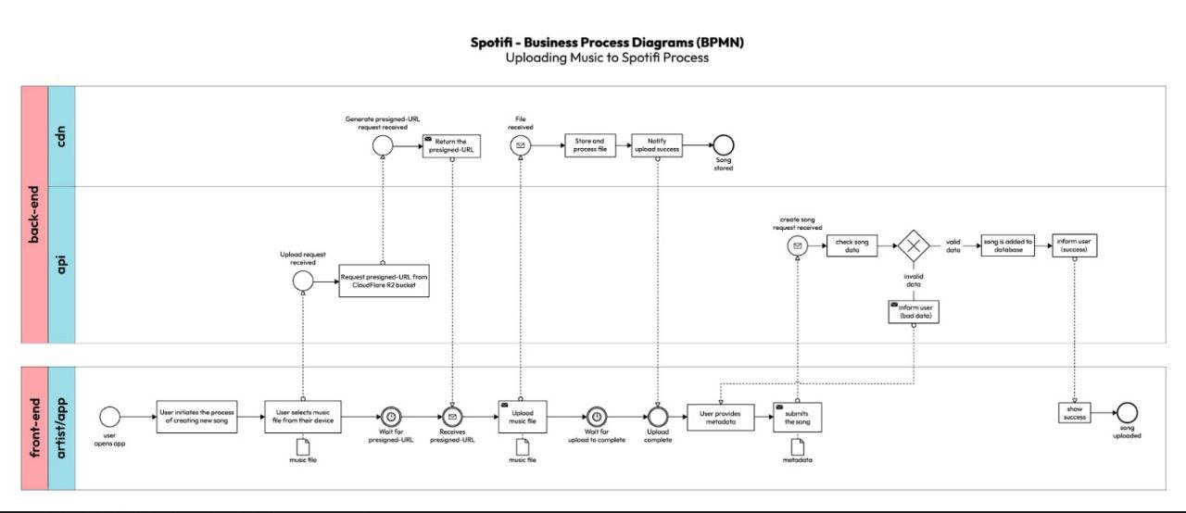

* **Clarity and Complexity**: These diagrams seem to follow a linear process with clear indications of the workflow. However, the complexity seems moderate, potentially indicating a higher-level overview rather than detailed processing steps.
* **Detail and Thoroughness**: The steps shown appear to cover the general process without going into granular details.
* **Layout and Design**: The layout is straightforward, which aids in following the process from start to end.
* **Symbols and Notation**: Standard flowchart symbols are used, suggesting a clear understanding of the process mapping conventions.

## C. Rick Martens

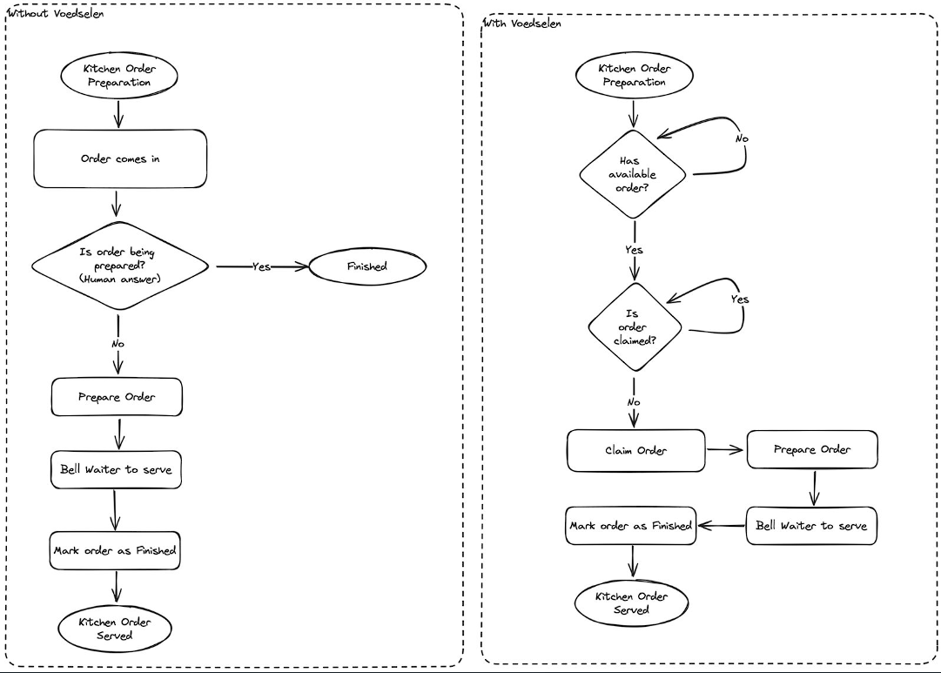

* **Clarity and Complexity**: The diagram is simplistic and straightforward, suggesting a high-level process map.
* **Detail and Thoroughness**: It might not include all potential decision points or variations in the process.
* **Layout and Design**: The design is very basic, which could be seen as a lack of detail or a focus on simplicity.
* **Symbols and Notation**: The use of basic shapes indicates a general process flowchart rather than a detailed BPMN diagram.

## D. Midas Nies

* **Clarity and Complexity**: Midas's diagram is quite simple and easy to understand, indicating a high-level view of the process.
* **Detail and Thoroughness**: The diagram seems to lack detail compared to Arman's, which may be intentional if the aim was to provide a summary rather than a detailed map.
* **Layout and Design**: The design is minimalistic, with less emphasis on the visual appeal but maintaining clarity.
* **Symbols and Notation**: The diagram uses basic shapes, which could be from a standard flowchart set, indicating a straightforward process definition.

## E. Arman Parsaravesh

* **Clarity and Complexity**: Arman's diagram presents a more detailed flow with specific actions and decision points, which could indicate a more in-depth understanding of the process.
* **Detail and Thoroughness**: This diagram includes specific decision points, which adds to the thoroughness of the representation.
* **Layout and Design**: The use of BPMN notation suggests a professional layout and design, with a focus on clarity.
* **Symbols and Notation**: BPMN symbols are used correctly, showing familiarity with process modeling standards.

# III. Group Diagrams

## A. Group 1 Diagram

* **Clarity and Complexity**: The diagram is clear but reflects a multi-step process that might introduce complexity in execution.
* **Detail and Thoroughness**: It outlines a complete customer journey but may not capture all back-end processes.
* **Layout and Design**: The linear layout aids in understanding the sequential order of service, though it may lack visual appeal.
* **Symbols and Notation**: Utilizes basic flowchart symbols that are sufficient for communicating the steps but might not adhere to more complex notation standards like BPMN.

## B. Group 3 Diagram

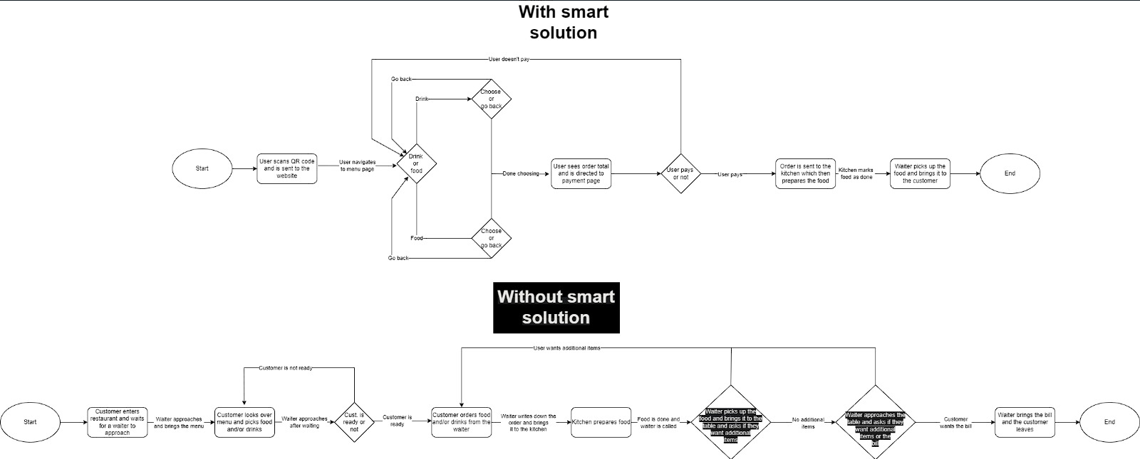

* **Clarity and Complexity**: Offers a dual-view of processes with and without the smart solution, providing a clear comparison of complexities.
* **Detail and Thoroughness**: The diagram is thorough in its depiction of the smart solution's streamlining effect on the process.
* **Layout and Design**: The split between traditional and smart solutions within one diagram allows for direct comparison, though it may become cluttered.
* **Symbols and Notation**: Employs a straightforward design that is easy to follow, with a focus on differentiation between the two processes.

Top of Form

# IV. Comparison Within Group 1

## A. Group 1 Discussion

* **Alec's diagrams** provide a clear linear process that can be easily followed, which might be useful for general understanding.
* **Arman's diagram** stands out for its thoroughness and use of proper BPMN notation, which could be more useful for those familiar with process modeling.
* **Midas's and Rick's diagrams** are more on the simplistic side, which could be useful for quick overviews without much detail.
* **Peter's diagram** seems to strike a balance between detail and simplicity, which might be effective for users who need more information than what is provided by Midas's or Rick's but less complexity than Arman's.

The diagrams collectively illustrate diverse methods of process mapping, each with its own strengths depending on the application context. Arman's detailed BPMN diagram is well-suited for in-depth process analysis and optimization efforts. In contrast, Alec, Midas, Peter, and Rick's diagrams offer varying degrees of simplification, ideal for educational purposes or high-level presentations where detailed process mechanics are less critical. The choice between these diagrams should be guided by the specific needs of the audience, whether for comprehensive process engagement or for broad-stroke process communication.

# V. Comparison Between Groups

## A. Group 1 vs. Group 3

* Group 1's diagram is detailed and traditional, emphasizing a manual, step-by-step customer service process with a clear sequence but potentially slower due to its complexity.
* Group 2's diagram showcases a bifurcated process flow, comparing traditional and technology-aided approaches. It highlights how a smart solution can simplify and accelerate the customer experience by reducing manual steps.

Overall, Group 1's approach may be preferred in settings where customer interaction is prioritized, while Group 2's smart solution fits scenarios where efficiency and quick service are paramount. The diagrams serve as a stark illustration of how technology can streamline traditional business processes.

Top of Form

# VI. Conclusions

## A. Findings

## The comparison revealed diverse approaches to process mapping, with individual diagrams focusing on specific aspects of business processes and group diagrams illustrating broader operational models. Individual diagrams ranged from detailed BPMN notations to high-level overviews, while group diagrams contrasted traditional and technology-aided service processes

## B. Lessons Learned

Collaboration on diagram creation highlighted the importance of clarity and purpose in process visualization. It's vital to match the diagram's complexity with the target audience's needs and to use appropriate notation for consistency and understanding. Future activities should include best practices for diagrammatic clarity and the benefits of technology integration in process efficiency..

## C. Next Steps

Suggested next steps include refining diagrams to incorporate feedback from the comparison, hosting discussions to align on process details, and continuing collaboration to further improve and iterate on the process maps, ensuring they effectively communicate the intended processes to all stakeholders.